**MIT Tutorial - 2**

1) Specify the output at PORT1 if the following program is executed.

MVI B, 82H

MOV A, B

MOV C, A

MVI D, 37H

OUT PORT1

HLT

2) Identify the contents of the registers and the flags at the following instructions are executed.

|  |  |  |  |  |  |  |  |
| --- | --- | --- | --- | --- | --- | --- | --- |
| INSTRUCTION | A(H) | B(H) | C(H) | D(H) | S | Z | CY |
| MVI A, 00H | **00** | 00 | 00 | 00 | 0 | 0 | 0 |
| MVI B, F8H | 00 | **F8** | 00 | 00 | 0 | 0 | 0 |
| MOV C, A | 00 | F8 | **00** | 00 | 0 | 0 | 0 |
| MOV D, B | **F8** | F8 | 00 | 00 | 0 | 0 | 0 |
| HLT | F8 | F8 | 00 | 00 | 0 | 0 | 0 |

3) Identify the contents of the registers and the flags at the following instructions are executed.

A B S Z CY

00 FF 0 1 0 --- initial contents

MVI A, F2H

MVI B, 7AH

ADD B

OUT PORT0

HLT

|  |  |  |  |  |  |  |
| --- | --- | --- | --- | --- | --- | --- |
| INSTRUCTION | A(H) | B(H) | S | Z | CY | PORT0 [00H] |
| INTIAL STATE | 00 | FF | 0 | 1 | 0 | 0 |
| MVI A, F2H | **F2** | FF | 0 | 1 | 0 | 0 |
| MVI B, 7AH | F2 | **7A** | 0 | 1 | 0 | 0 |
| ADD B | **6C** | 7A | 0 | 0 | **1** | 0 |
| OUT PORT0 | 6C | 7A | 0 | 0 | **1** | **108[(6C)H]** |
| HLT | 6C | 7A | 0 | 0 | 1 | 108 |

4) Identify the contents of the registers and the flags at the following instructions are executed.

A C S Z CY

00 00 0 1 0 --- initial contents

MVI A, 5EH

ADI A2H

MOV C, A

HLT

|  |  |  |  |  |  |
| --- | --- | --- | --- | --- | --- |
| INSTRUCTION | A(H) | C(H) | S | Z | CY |
| INTIAL STATE | 00 | 00 | 0 | 1 | 0 |
| MVI A, 5EH | **5E** | 00 | 0 | 1 | 0 |
| ADI A2H | **00** | 00 | 0 | **1** | **1** |
| MOV C, A | 00 | **00** | 0 | **1** | **1** |
| HLT | 00 | 00 | 0 | 1 | 1 |

5) Identify the contents of the registers and the flags at the following instructions are executed.

A B S Z CY

MVI A, A9H

MVI B, 57H

ADD B

ORA A

|  |  |  |  |  |  |
| --- | --- | --- | --- | --- | --- |
| INSTRUCTION | A(H) | B(H) | S | Z | CY |
| INTIAL STATE | 00 | 00 | 0 | 0 | 0 |
| MVI A, A9H | **A9** | 00 | 0 | 0 | 0 |
| MVI B, 57H | A9 | **57** | 0 | 0 | 0 |
| ADD B | **00** | 57 | 0 | **1** | **1** |
| ORA A | 00 | 57 | 0 | 1 | 0 |

6) Identify the contents of the registers and the flags at the following instructions are executed.

A B S Z CY

XRA A

MVI B, 4AH

SUI 4FH

ANA B

HLT

|  |  |  |  |  |  |
| --- | --- | --- | --- | --- | --- |
| INSTRUCTION | A(H) | B(H) | S | Z | CY |
| INTIAL STATE | 00 | 00 | 0 | 0 | 0 |
| XRA A | **00** | 00 | 0 | **1** | 0 |
| MVI B, 4AH | 00 | **4A** | 0 | 1 | 0 |
| SUI 4FH | **B1** | 4A | **1** | **0** | **1** |
| ANA B | **00** | 4A | **0** | **1** | **0** |
| HLT | 00 | 4A | 0 | 1 | 0 |

What operation can be performed by using XRA A instruction ? To Set the Z Flag

7)

1. What does the above program do?

2. At the end of the program, what will be

a. The contents of the registers A, B, C, H and L?

b. The condition of the carry and zero flags?

c. The content of the memory locations 2000H, 2001H, 2002H and 2100H.

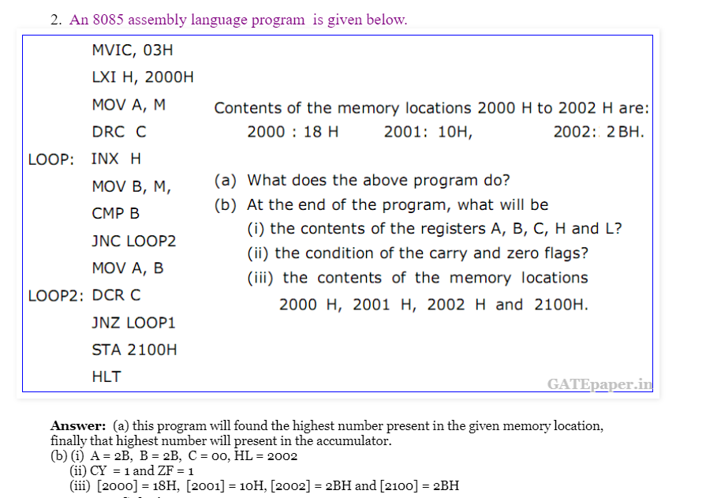

8 This program is to multiply the numbers OAH by OBH and stored the result in Accumulator.

If contents of B=0AH, C=0BH then complete the following program.

MVI A, 00H

LOOP: …………..

…………….

…………….

HLT

END

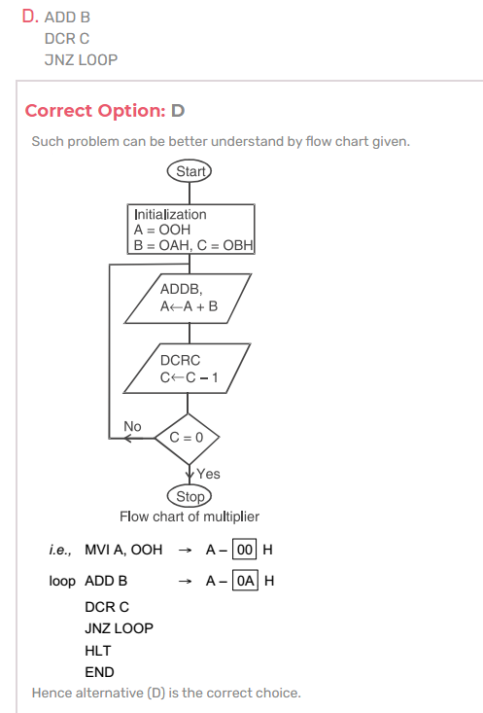

9.) Identify the contents of the registers, the memory location (2055H), and the flags at the

following instructions are executed.

A H L S Z CY M(2055H)

LXI H,2055H

MVI M,8AH

MVI A,76H

ADD M

STA 2055H

HLT

|  |  |  |  |  |  |  |  |
| --- | --- | --- | --- | --- | --- | --- | --- |
| INSTRUCTION | A | H | L | S | Z | CY | M(2055H) |
| LXI H,2055H | 00 | **20** | **55** | 0 | 0 | 0 | 0 |
| MVI M,8AH | 00 | 20 | 55 | 0 | 0 | 0 | **138** |
| MVI A,76H | **76** | 20 | 55 | 0 | 0 | 0 | 138 |
| ADD M | 00 | 20 | 55 | 0 | **1** | **1** | 138 |
| STA 2055H | 00 | 20 | 55 | 0 | 1 | 1 | 0 |
| HLT | 00 | 20 | 55 | 0 | 1 | 1 | 0 |